**CODE CAMP DAY-1**

**Program -1)**

**// Student class**

**package** codecamp1;

**public** **class** Student {

**private** String FirstName;

**private** String LastName;

**private** **char** Grade;

Student(String FirstName, String LastName,**char** Grade)

{

**this**.FirstName=FirstName;

**this**.LastName=LastName;

**this**.Grade=Grade;

}

**void** display()

{

System.***out***.println("The FirstName is : "+FirstName);

System.***out***.println("The Student LastName is : "+LastName);

}

}

**// StudentDemo Class**

**package** codecamp1;

**public** **class** Studemo {

**public** **static** **void** main(String args[])

{

Student st=**new** Student("Sai", "Yerraganati", '1');

Student st2=**new** Student("Guru","Yerraganti",'2');

st.display();

st2.display();

}

}

**OUTPUT:-**

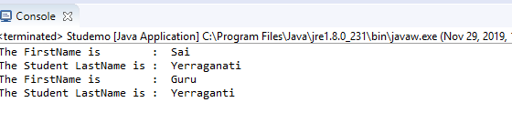

**Program -2)**

**// Square class**

**package** codecamp1;

**import** java.util.Scanner;

**public** **class** Squ **extends** Shape {

**double** perimeter,area;

**private** **double** sq;

Squ(**double** sq)

{

**this**.sq=sq;

}

@Override

**void** getPerimeter( )

{

//Perimeter of a Square

System.***out***.println("\t\t\tSqaure");

Scanner sc=**new** Scanner (System.***in***);

System.***out***.print("Enter the perimeter value of a in square : ");

**double** a=sc.nextDouble();

**double** perimeter=4*a;

System.***out***.println("The perimter of the square is : "+perimeter);

}

@Override

**void** getArea()

{

System.***out***.println(" ");

Scanner sc=**new** Scanner (System.***in***);

System.***out***.println("Enter the side value of a");

**double** a1=sc.nextDouble();

**double** area=Math.*sqrt*(a1);

System.***out***.println("The area of the square is : "+area);

}}

**// Class Pentagon**

**package** codecamp1;

**import** java.util.Scanner;

**public** **class** Pentagon **extends** Shape {

**double** perimeter,area;

**private** **double** pe;

Pentagon(**double** pe)

{

**this**.pe=pe;

}

@Override

**void** getPerimeter( )

{

//Perimeter of a Square

System.***out***.println(" ");

System.***out***.println("\t\t\tpenatgon");

Scanner sc=**new** Scanner (System.***in***);

System.***out***.println("Enter the side value of a");

**double** a2=sc.nextDouble();

**double** perimeter=5*a2;

System.***out***.println("The perimter of the pentagon is : "+perimeter);

}

@Override

**void** getArea()

{

System.***out***.println(" ");

Scanner sc=**new** Scanner (System.***in***);

System.***out***.println("Enter the side value of a");

**double** a3=sc.nextDouble();

**double** area=(1.7204)*a3*a3;

System.***out***.println("The area of the pentagon is : "+area);

}

}

**// Class Circle**

**package** codecamp1;

**import** java.util.Scanner;

**public** **class** Circle **extends** Shape {

**double** perimeter,area;

**private** **double** c;

Circle(**double** c)

{

**this**.c=c;

}

@Override

**void** getPerimeter( )

{

//Perimeter of a circle

System.***out***.println(" ");

System.***out***.println("\t\t\tCircle ");

System.***out***.println(" ");

Scanner sc=**new** Scanner (System.***in***);

System.***out***.println("Enter the side value of r");

**double** r=sc.nextDouble();

**double** perimeter= 2*3.14*r*r;

System.***out***.println("The perimter of the circle is : "+perimeter);

}

@Override

**void** getArea()

{

System.***out***.println(" ");

//Area of the square

Scanner sc=**new** Scanner (System.***in***);

System.***out***.println("Enter the side value of r");

**double** r=sc.nextDouble();

**double** area=3.14*r*r;

System.***out***.println("The area of the circle is : "+area);

}

}

**// Class Shape**

**public** **abstract** **class** Shape {

**abstract** **void** getPerimeter();

**abstract** **void** getArea();

}

**// Class ShapeDemo**

**package** codecamp1;

**public** **class** Shapedemo {

**public** **static** **void** main(String args[])

{

Squ sqt=**new** Squ(4);

sqt.getPerimeter();

sqt.getArea();

Pentagon pt=**new** Pentagon(5);

pt.getPerimeter();

pt.getArea();

Circle cr=**new** Circle(5);

cr.getPerimeter();

cr.getArea();

}

}

**OUTPUT:-**

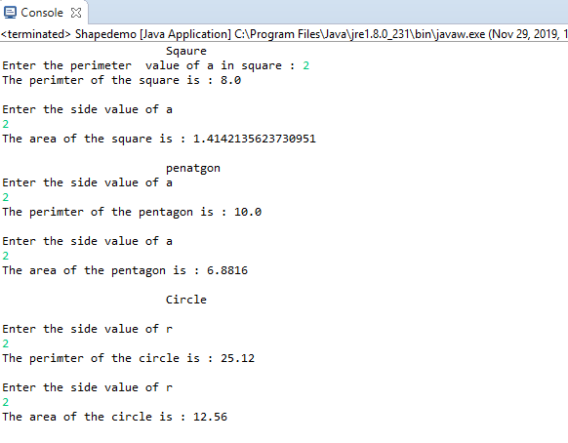

**Program -6) Even and Odd of Car**

**package** codecamp1;

**import** java.io.IOException;

**import** java.util.Scanner;

**public** **class** Car {

**public** **static** **void** main(String args[]) **throws** IOException{

**int** a=0,b=0;

Scanner sc=**new** Scanner(System.***in***);

**int**[] evenNum=**new** **int**[10];

**int**[] oddNum=**new** **int**[10];

**int**[] carNum=**new** **int**[10];

System.***out***.println("Please Enter car numbers");

**for**(**int** i=0;i<10;i++) {

carNum[i]=sc.nextInt();

}

**for**(**int** i=0;i<10;i++) {

**int** temp=carNum[i];

**if**(temp%2==0){

evenNum[a]=carNum[i];

System.***out***.println("Even car numbers: "+evenNum[a]);

a++;

}

**else** {

oddNum[b]=carNum[i];

System.***out***.println("Odd car number: "+oddNum[b]);

b++;

}

}

}

}

**Output:-**

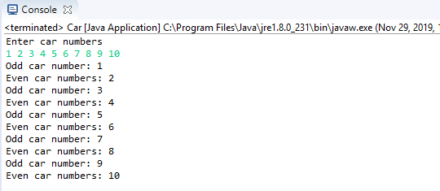

**Program 7) Matrix Muliplication**

**package** codecamp1;

**import** java.util.Scanner;

**public** **class** Matrixmultiplication

{

**public** **static** **void** main(String args[])

{

**int** n=3;

Scanner sc = **new** Scanner(System.***in***);

**int**[][] x = **new** **int**[n][n];

**int**[][] y = **new** **int**[n][n];

**int**[][] z = **new** **int**[n][n];

System.***out***.println("Enter the elements of 1st martix \n");

**for** (**int** i = 0; i < n; i++)

{

**for** (**int** j = 0; j < n; j++)

{

x[i][j] = sc.nextInt();

}

}

System.***out***.println("Enter the elements of 2nd martix \n");

**for** (**int** i = 0; i < n; i++)

{

**for** (**int** j = 0; j < n; j++)

{

y[i][j] = sc.nextInt();

}

}

**for** (**int** i = 0; i < n; i++)

{

**for** (**int** j = 0; j < n; j++)

{

**for** (**int** k = 0; k < n; k++)

{

z[i][j] = z[i][j] + x[i][k] * y[k][j];

}

}

}

System.***out***.println("Multiplication of two matrices");

**for** (**int** i = 0; i < n; i++)

{

**for** (**int** j = 0; j < n; j++)

{

System.***out***.print(z[i][j] + " ");

}

System.***out***.println();

}

}

}

**OUTPUT**:-

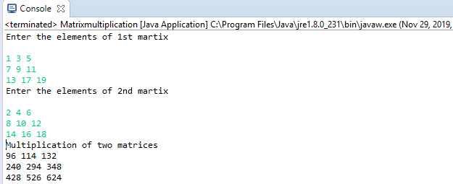

**Program-10)**

The following code prepare **for** addition of two numbers.

**int** a, b;

**int** sum=a+b;

System.out.println(“Enter two numbers to add: ");

System.out.println (a);

System.out.println (b);

System.out.println (“The sum is: “+sum);

**1.It is valid declaration.:-**No, This is not a Valid declaration because there is No **main()** method

i.e public static void main(String args[ ])

And we to initialize the variables

**2.output:-Syntax Error**

**Program 11)**

**public class LinePrinter**

**{**

**public static void main(String[] args)**

**{**

**char c = 0x000A;**

**System.*out*.println(c);**

**}**

**}**

**1.**  **Does the syntax work**:- The Syntax is Compiling but the output is not display

**2.** **What does it print? :-It Prints the Blank space**

**3. Is its behavior platform dependent?** :The behavior of this program is platform independent: It won't compile on any platform. If you tried to compile it,

**Program-13)**

This program adds an unusual twist to the usual Hello world program. What does it print?

**try**

{ System.out.println("Hello world");

System.exit(0);

}

Finally

{ System.out.println("Goodbye world"); }

**1. Does the syntax work?** Yes the Syntax will where the try block is in the main method

**2. If syntax is not right so what we will remove in this syntax:-** Remove the Finally it’s a finally we have to insert it in place of Finally